2026-10-04 · · ~ 40 Mins
Tool: <Gemini/Notebook>
What I asked for: I am making a AS-IS and TO-BE scenarios list and need help in building it if possible. I can provide the issues list and we can build from there.
What came back: 11 Candidates, 11 Rejected, Mainly confirming of what I asked and was ready for input on issues list from Discord
What I changed: Supplied issues list from discord for context on the types of issues found within the group
Verified against: Issues List (Discord)
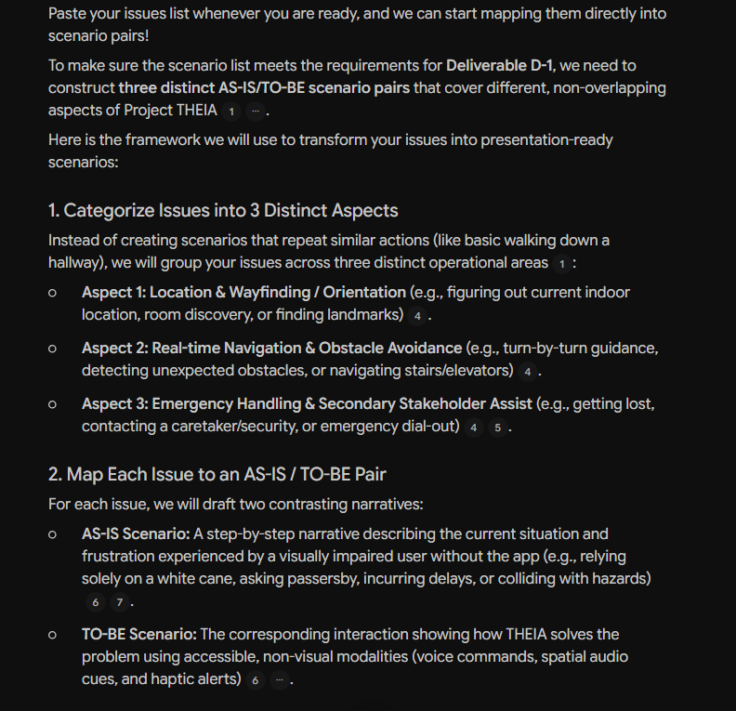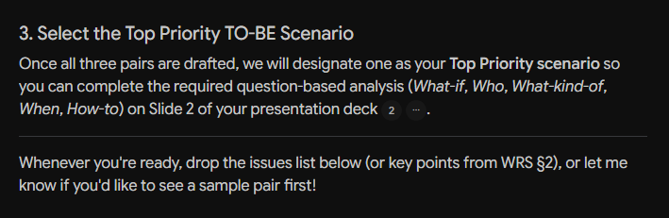
2026-10-04-.png
Tool: <Gemini/Notebook>
What I asked for: Copied and Pasted the issues list from discord
What came back: 4 Candidates, 2 accepted, 2 rejected, gave ideas and potential context to build from for AS-IS and TO-BE scenarios
What I changed: Read through, and choose two of the 3 scenarios that best fits the project based on the combination of issues mentions from the issues list
Verified against: Issues List (Discord)
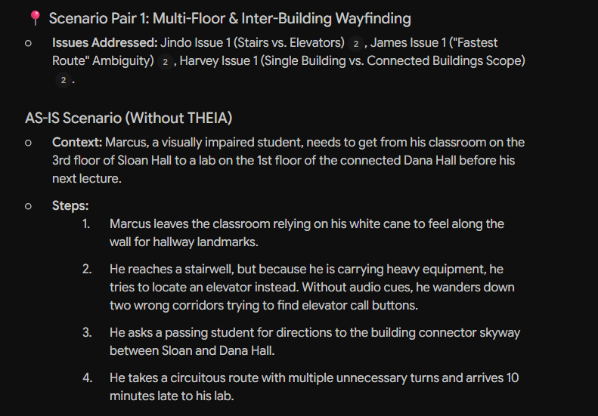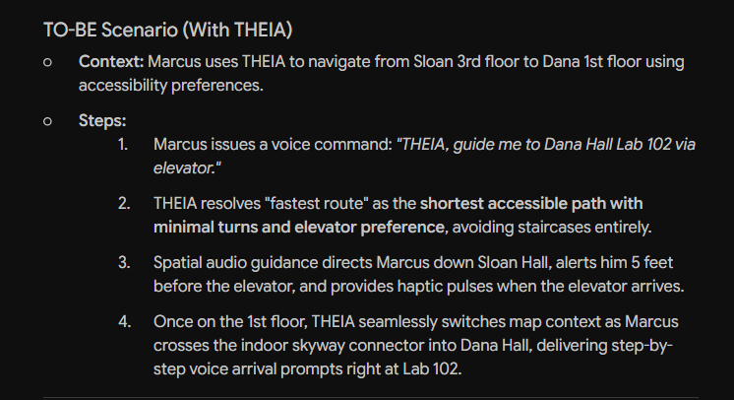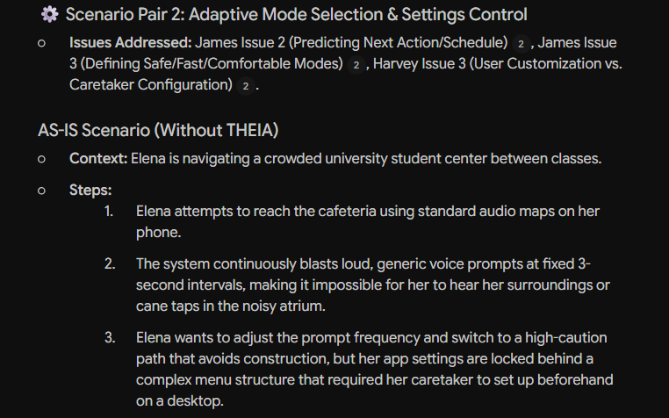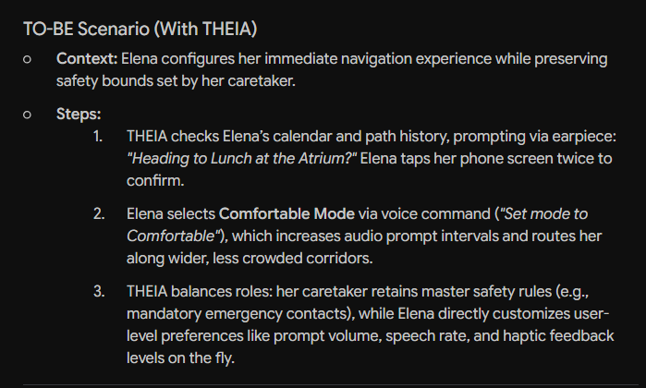
2026-10-04-.png
2026-10-04 · · ~ 3 Mins
Tool: <Gemini/Notebook>
What I asked for: List out the strengths between all four scenarios to see what could lead to them being top priority
What came back: 3 Candidates, 1 Accepted, 2 Rejected, Mainly confirming of what I asked and was ready for input on issues list from Discord
What I changed: Went over the list of each scenarios strengths and decided on which would be the top priority
Verified against: Issues List (Discord)
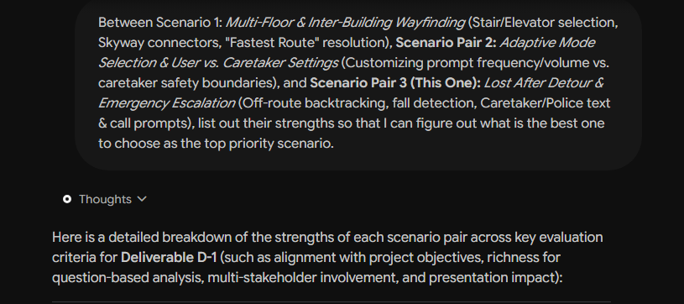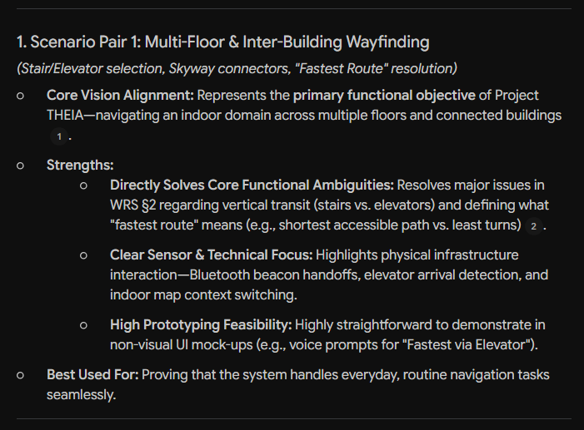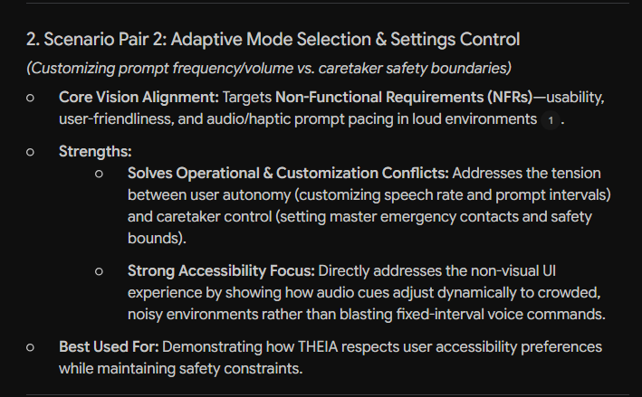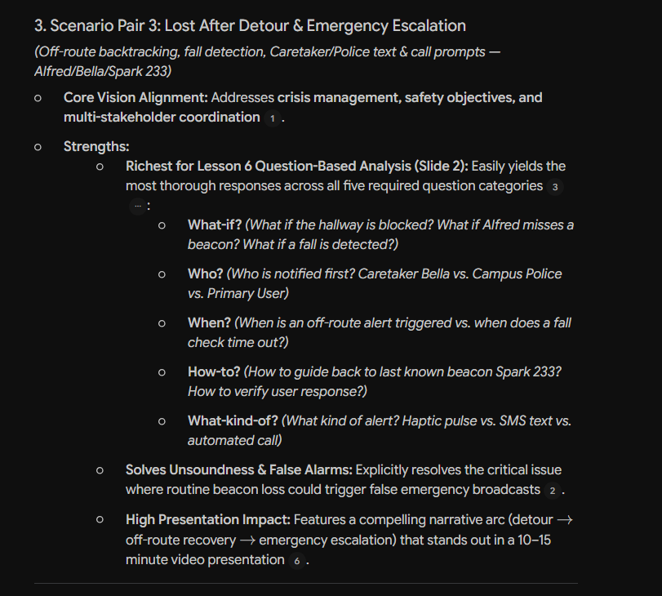
2026-10-04-.png
2026-10-15 · · ~ 20 Mins
Tool: <Gemini>
What I asked for: Use the feedback that was provided to make the needed changes on the PowerPoint that I made. Provide me the things that need to be added or changed to ensure the feedback is completely properly.
What came back: 9 Candidates, 9 Accepted, goes over the feedback image that was given to me from discord and uses it to make a template of the presentation I provided
What I changed: Replaced slides, modified wording to be more of my words, applied animations to the slides, and modified the items of the slides to be more cleaner and less spaced out than what the template created
Verified against: Feedback png provided by Zichuo Wang on AS-IS-TO-BE Channel in discord
